# CS 499 Module One Assignment

1. **Self-Introduction:** Address all of the following questions to introduce yourself.
   1. How long have you been in the Computer Science program?

I started my first term in October 2022, so I have been in this program for two years.

* 1. What have you learned while in the program? List three of the most important concepts or skills you have learned.

Software Development Lifecycle - Understanding the lifecycle from planning and design to testing and deployment has improved my approach to software project management.

Data Structures andAlgorithms - Learning about algorithms and data structures has sharpened my ability to build efficient solutions, manage resources, and optimize performance in applications.

Database Management - Gaining proficiency with relational and non-relational databases, especially MongoDB and SQL, has enhanced my ability to design and manage data-driven applications.

* 1. Discuss the specific skills you aim to demonstrate through your enhancements to reach each of the course outcomes.

For the ePortfolio, I aim to demonstrate proficiency in designing effective algorithms and implementing efficient data structures, ability to create intuitive user interfaces that enhance user experience, skills in secure coding practices to protect data and ensure system integrity.

* 1. How do the specific skills you will demonstrate align with your career plans related to your degree?

My goal is to move into a product management role where I can bridge technical knowledge with user-centric design. The skills I demonstrate here, including optimizing database interactions and enhancing application performance, will help me make more informed decisions about software products.

* 1. How does this contribute to the specialization you are targeting for your career?

These skills directly contribute to my specialization in software product management, as they help me understand user needs, align product features with business objectives, and prioritize technical improvements that enhance product quality and security.

1. **ePortfolio Set Up:**
   1. Submit a **screen capture** of your ePortfolio GitHub Pages home page that clearly shows your URL.

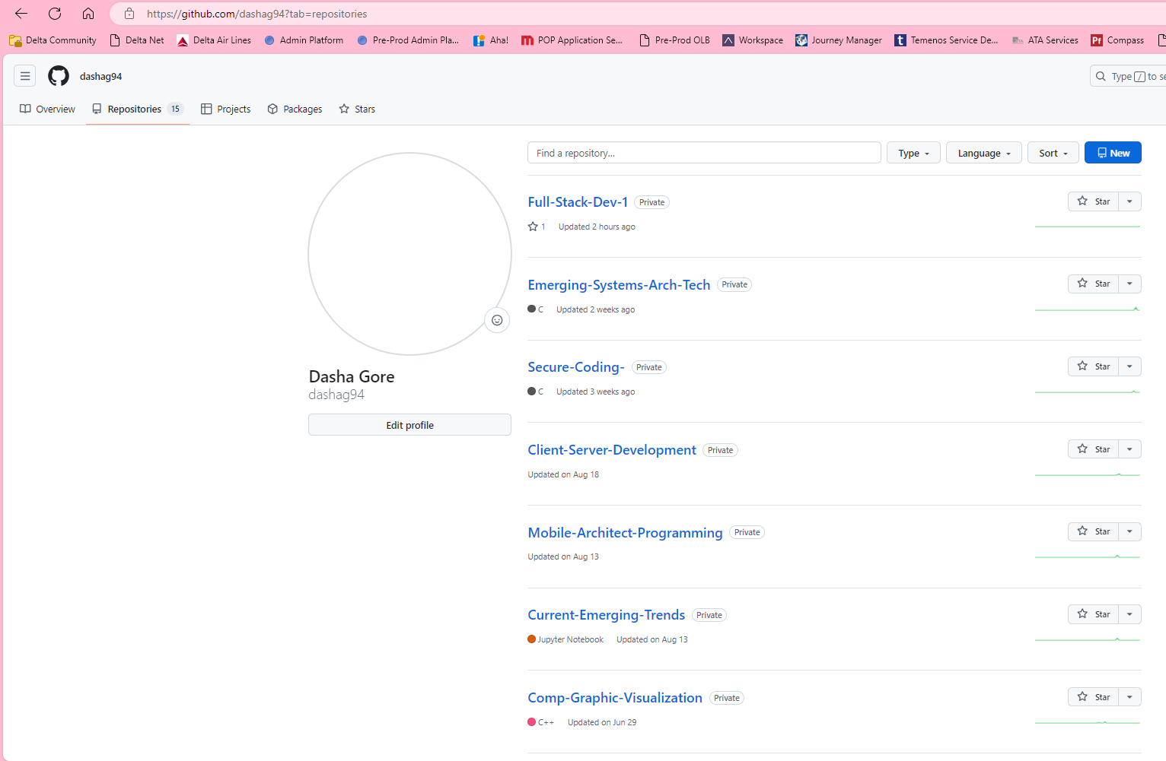

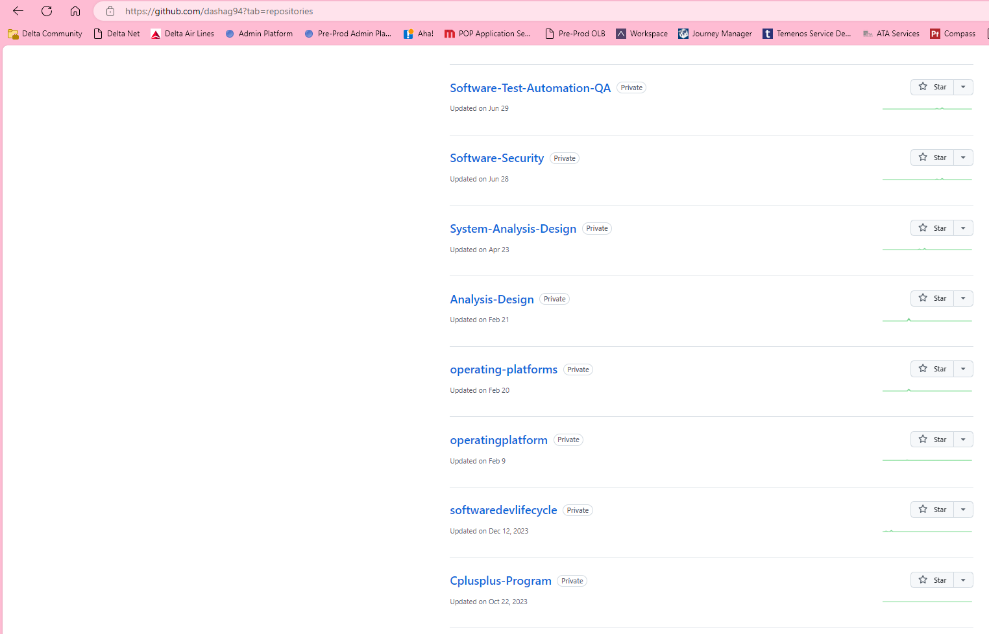

* + 1. You already have a repository in GitHub where you uploaded projects in previous courses. Your ePortfolio will reside in GitHub but can link to work at other sites, such as Bitbucket.
  1. Use the GitHub Pages link in the Resource section for directions on:
     1. How to create your GitHub website and publish code to GitHub Pages
     2. Issues, such as adding links to other sites
  2. Paste a screenshot of your GitHub Pages home page with your URL clearly showing in the space below.

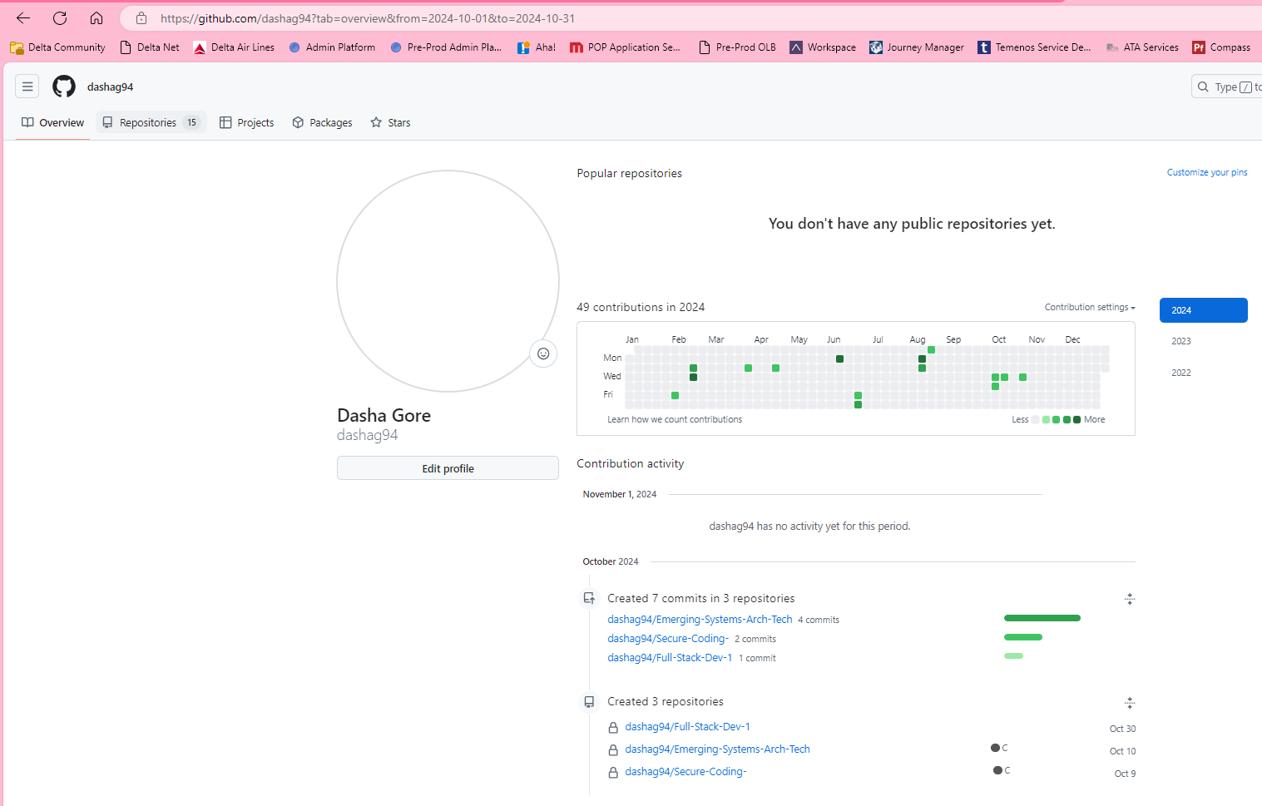

1. **Enhancement Plan:** 
   1. **Category One:** Software Engineering and Design
      1. **Select an** **artifact** that is **aligned with** **the** software engineering and design **category** and explain its origin. Submit a file containing the code for the artifact you choose with your enhancement plan.

I will use a mobile app from my CS 360 course focused on Mobile Architecture and Programming. This project includes foundational UI and backend design.

Note: Your artifact may be work from the following courses:

* IT 145: Foundation in Application Development
* CS 250: Software Development Lifecycle
* CS 260: Data Structures and Algorithms
* IT 315: Object Oriented Analysis and Design
* CS 320: Software Testing, Automation, and Quality Assurance
* CS 330: Computational Graphics and Visualization
* CS 340: Advanced Programming Concepts
* CS 350: Emerging Systems Architectures and Technologies
* CS 360: Mobile Architecture and Programming
* IT 365: Operating Environments
* IT 380: Cybersecurity and Information Assurance
* CS 405: Secure Coding
* CS 410: Reverse Software engineering
* IT 340: Network and Telecommunication Management
* IT 380: Cybersecurity and Information Assurance
  + 1. **Describe** a practical, well-illustrated **plan** for enhancement in alignment with the category, including a pseudocode or flowchart that illustrates the planned enhancement.

I plan to extend this app’s functionality by adding user authentication, more interactive UI elements, and enhanced error handling. Implement a secure login and registration system using OAuth 2.0 or JWT to enable user accounts and profile management. Add more interactive components such as swipe actions for data entries, a progress tracker for user goals, and customizable themes to improve user engagement. Implement comprehensive error-handling routines to catch runtime exceptions and display user-friendly messages, ensuring better user experience and stability.

// User Authentication Workflow

START

DISPLAY Login Page

IF User clicks 'Sign Up'

SHOW Registration Form

IF Registration Form is submitted

VALIDATE inputs

IF inputs are valid

CREATE user account in the database

REDIRECT to Welcome Page

ELSE

DISPLAY error message

ENDIF

ENDIF

IF User logs in with credentials

VALIDATE credentials

IF credentials are correct

INITIATE session

REDIRECT to Dashboard

ELSE

DISPLAY 'Invalid username or password'

ENDIF

ENDIF

END

For this category of enhancement, consider improving a piece of software, transferring a project into a different language, reverse engineering a piece of software for a different operating system, or expanding a project’s complexity. These are just recommendations. Consider being creative and proposing an alternative enhancement to your instructor.

Think about what additions to include to complete the enhancement criteria in this category. Since one example option is to port to a new language, that is the kind of scale that is expected. This does not mean you need to port to a new language but instead have an equivalent scale of enhancement. Underlying expectations of any enhancement include fixing errors, debugging, and cleaning up comments, but these are not enhancements themselves.

* + 1. Explain how the planned enhancement will **demonstrate** specific **skills** and align with course outcomes.
       1. Identify and describe the specific skills you will demonstrate that align with the course outcome.

Adding interactive UI elements shows my ability to design interfaces that enhance user interaction and usability. Implementing user authentication demonstrates my understanding of secure coding practices and data protection measures. Enhancing error-handling routines demonstrates my ability to create resilient applications that gracefully handle unexpected events.

* + - 1. Select one or more of the course outcomes below that your enhancement will align with.

Design and evaluate computing solutions that solve a given problem using algorithmic principles and computer science practices and standards appropriate to its solution while managing the trade-offs involved in design choices.This enhancement showcases my ability to choose the most appropriate authentication method and UI components while balancing security and user experience.Demonstrate an ability to use well-founded and innovative techniques, skills, and tools in computing practices for the purpose of implementing computer solutions that deliver value and accomplish industry-specific goals.By incorporating current standards like OAuth 2.0 and enhancing the UI, I demonstrate proficiency in modern software development practices. Develop a security mindset that anticipates adversarial exploits in software architecture and designs to expose potential vulnerabilities, mitigate design flaws, and ensure privacy and enhanced security of data and resources. Adding authentication and robust error handling shows anticipation of potential vulnerabilities and a proactive approach to security.

Course Outcomes:

1. Employ strategies for building collaborative environments that enable diverse audiences to support organizational decision-making in the field of computer science.
2. Design, develop, and deliver professional-quality oral, written, and visual communications that are coherent, technically sound, and appropriately adapted to specific audiences and contexts.
3. Design and evaluate computing solutions that solve a given problem using algorithmic principles and computer science practices and standards appropriate to its solution while managing the trade-offs involved in design choices.
4. Demonstrate an ability to use well-founded and innovative techniques, skills, and tools in computing practices for the purpose of implementing computer solutions that deliver value and accomplish industry-specific goals.
5. Develop a security mindset that anticipates adversarial exploits in software architecture and designs to expose potential vulnerabilities, mitigate design flaws, and ensure privacy and enhanced security of data and resources.
   1. **Category Two:** Algorithms and Data Structures
6. **Select an artifact** that is **aligned with the** algorithms and data structures **category** and explain its origin. Submit a file containing the code for the artifact you choose with your enhancement plan. You may choose work from the courses listed under Category One.

I have chosen a pathfinding algorithm project from **CS 300: Data Structures and Algorithms.** This project implemented the classic **Dijkstra’s Algorithm** for finding the shortest path in a weighted graph, initially developed for coursework focused on algorithm design and efficiency. This artifact effectively showcases my foundational skills in working with complex data structures and applying algorithms to solve computational problems.

1. **Describe** a practical, well-illustrated **plan** for enhancement in alignment with the category, including a pseudocode or flowchart that illustrates the planned enhancement.

Improve the algorithm's efficiency by replacing Dijkstra’s Algorithm with A Algorithm*, which integrates heuristic optimization for better performance in pathfinding. Additionally, restructure the underlying data structure from an adjacency matrix to an adjacency list to improve memory usage and processing speed. Integrate A* algorithm using a priority queue to manage node exploration efficiently and reduce overall computational time. Replace the existing adjacency matrix with an adjacency list, optimizing space complexity from O(n2)O(n^2)O(n2) to O(n+m)O(n + m)O(n+m), where nnn is the number of nodes and mmm is the number of edges. Add a step-by-step visualization of the algorithm's execution to provide better insights into how paths are chosen and evaluated.

// A* Pathfinding Algorithm

START

OPEN_SET = Priority Queue containing the start node

G_SCORE[start] = 0

F_SCORE[start] = heuristic(start, goal)

WHILE OPEN_SET is not empty

CURRENT = node in OPEN_SET with the lowest F_SCORE

IF CURRENT is the goal

RETURN path from start to goal

REMOVE CURRENT from OPEN_SET

FOR each neighbor of CURRENT

TEMP_G_SCORE = G_SCORE[CURRENT] + distance(CURRENT, neighbor)

IF TEMP_G_SCORE < G_SCORE[neighbor]

G_SCORE[neighbor] = TEMP_G_SCORE

F_SCORE[neighbor] = G_SCORE[neighbor] + heuristic(neighbor, goal)

ADD neighbor to OPEN_SET if not already present

ENDIF

ENDFOR

ENDWHILE

RETURN failure (no path found)

END

For this category of enhancement, consider improving the efficiency of a project or expanding the complexity of the use of data structures and algorithms for your artifact. These are just recommendations. Consider being creative and proposing an alternative enhancement to your instructor. Note: You only need to choose one type of enhancement per category.

Think about what additions to include to complete the enhancement criteria in this category. Since one example option is to port to a new language, that is the kind of scale that is expected. Perhaps you might increase the efficiency and time complexity of an algorithm in an application and detail the logic of the increased time complexity. Remember, you do not need to port to a new language but instead have an equivalent scale of enhancement. Underlying expectations of any enhancement include fixing errors, debugging, and cleaning up comments, but these are not enhancements themselves.

1. Explain how the planned enhancement will **demonstrate** specific **skills** and align with course outcomes.
   1. Identify and describe the specific skills you will demonstrate to align with the course outcome.

This enhancement will demonstrate my ability to improve algorithmic efficiency by applying heuristic-based approaches and data structure optimizations. I will showcase my understanding of analyzing and reducing the time and space complexity of algorithms. Developing the visualization of the pathfinding process highlights my skills in debugging complex logic and presenting data in an understandable manner.

* 1. Select one or more of the course outcomes listed under Category One that your enhancement will align with.

Design and evaluate computing solutions that solve a given problem using algorithmic principles and computer science practices and standards appropriate to its solution while managing the trade-offs involved in design choices. The choice of A* over Dijkstra’s involves trade-offs between simplicity and efficiency, showcasing an understanding of design choices. Demonstrate an ability to use well-founded and innovative techniques, skills, and tools in computing practices for the purpose of implementing computer solutions that deliver value and accomplish industry-specific goals. The upgrade to A* demonstrates applying modern, industry-relevant algorithmic techniques.

* 1. **Category Three: Databases**
     1. **Select an artifact** that is **aligned with the** databases **category** and explain its origin. Submit a file containing the code for the artifact you choose with your enhancement plan. You may choose work from the courses listed under Category One.

**[Insert your answer here.]**

* + 1. **Describe** a practical, well-illustrated **plan** for enhancement in alignment with the category, including a pseudocode or flowchart that illustrates the planned enhancement.

For the databases category, I have chosen a database management system I created in **CS 340: Advanced Programming Concepts,** which involved designing and managing a relational database for an e-commerce application. The original project focused on database schema design, SQL queries for CRUD operations, and data normalization techniques to ensure efficient data storage and retrieval. Implement data mining algorithms such as association rule learning to identify frequently bought items together, aiding in recommendation systems.Create a Node.js-based API to query and aggregate data from MongoDB collections, supporting real-time analytics. Develop a front-end dashboard using React that visualizes key analytics like user session data, purchasing trends, and product performance.

// Apriori Algorithm for identifying frequent item sets

START

MIN_SUPPORT = set minimum threshold for item frequency

DATASET = load transaction data

CANDIDATE_ITEMSETS = generate initial set of itemsets from DATASET

FREQUENT_ITEMSETS = []

WHILE CANDIDATE_ITEMSETS is not empty

FOR each itemset in CANDIDATE_ITEMSETS

COUNT occurrences in DATASET

IF occurrence count >= MIN_SUPPORT

ADD itemset to FREQUENT_ITEMSETS

ENDIF

ENDFOR

CANDIDATE_ITEMSETS = generate new combinations from FREQUENT_ITEMSETS

ENDWHILE

RETURN FREQUENT_ITEMSETS

END

For this category of enhancement, consider adding more advanced concepts of MySQL, incorporating data mining, creating a MongoDB interface with HTML/JavaScript, or building a full stack with a different programming language for your artifact. These are just recommendations; consider being creative and proposing an alternative enhancement to your instructor. Note: You only need to choose one type of enhancement per category.

Think about what additions to include to complete the enhancement criteria in this category. Since one example option is to port to a new language, that is the kind of scale that is expected. Perhaps you might increase the efficiency and time complexity of an algorithm in an application and detail the logic of the increased time complexity. Remember, you do not need to port to a new language but instead have an equivalent scale of enhancement. Underlying expectations of any enhancement include fixing errors, debugging, and cleaning up comments, but these are not enhancements themselves.

* + 1. Explain how the planned enhancement will **demonstrate** specific **skills** and align with course outcomes.
       1. Identify and describe the specific skills you will demonstrate that align with the course outcome.

Showcasing my ability to integrate complex features like data mining and analytics into an existing database system. Implementing a MongoDB interface with Node.js and a React front-end to display data dynamically. Applying data mining algorithms demonstrates my skill in extracting valuable insights from large datasets.

* + - 1. Select one or more of the course outcomes listed under Category One that your enhancement will align with.

Design and evaluate computing solutions that solve a given problem using algorithmic principles and computer science practices and standards appropriate to its solution while managing the trade-offs involved in design choices. This is demonstrated through the selection and implementation of appropriate data mining algorithms and data visualization methods.

Demonstrate an ability to use well-founded and innovative techniques, skills, and tools in computing practices for the purpose of implementing computer solutions that deliver value and accomplish industry-specific goals. This outcome is met through the integration of a real-time MongoDB interface and dynamic user analytics dashboard.

1. **ePortfolio Overall Skill Set**
   1. Accurately describe the **skill set** to be illustrated by the **ePortfolio** **overall**.
      1. Skills and outcomes planned to be illustrated in the code review

In the code review, I plan to highlight: Problem-Solving and Algorithmic Design, demonstrating my ability to design and optimize algorithms for real-world problems, showcasing efficiency improvements and innovative solutions. Code Readability and Best Practices, showcasing clear, maintainable code that adheres to industry standards and best practices, including thorough documentation and structured commenting. Debugging and Testing, demonstrating proficiency in identifying and resolving code issues, as well as implementing comprehensive testing strategies to ensure functionality and reliability.

* + 1. Skills and outcomes planned to be illustrated in the narratives

The narratives will illustrate, Project Management and Software Development Lifecycle, describing the process of planning, developing, and enhancing software projects, emphasizing key decisions and trade-offs made throughout development. Communication Skills, demonstrating my ability to present complex technical concepts clearly and effectively for diverse audiences, highlighting my approach to collaboration and teamwork. Reflective Analysis, providing insights into the challenges faced and solutions applied, showcasing adaptability, problem-solving, and a learning-oriented mindset.

* + 1. Skills and outcomes planned to be illustrated in the professional self-assessment

In the professional self-assessment, I will illustrate, Technical Competence and Growth, discussing how my skills in areas such as data structures, algorithm development, database management, and full-stack development have evolved through the program. Strategic Thinking and Goal Alignment, reflecting on how my work aligns with my career goals in software development and product management, and how my experiences contribute to my specialization in creating user-centric and secure software solutions. Ethical and Security-Minded Practices, demonstrating an understanding of software security principles, including data privacy considerations, secure coding practices, and proactive vulnerability mitigation strategies.